TITLE: Jeremy Utt, CSCI 200 Section B, “Cost and Bill Tracker”

PROBLEM DESCRIPTION:
I am developing a bill splitter app that simplifies the process of dividing expenses among a group of users. The program will store a list (in the form of a vector) of purchased items and their prices, allowing each participant to specify whether they are 'in' on any individual item or not. After all users have made their selections, the app calculates the amount each individual owes to the person who made the purchases. If multiple users contribute to a single item, the app evenly distributes the cost among them. This project aims to solve the real world problem of me and my roommates splitting the bills after buying groceries. I plan to use SFML to implement graphics into the program. If I have extra time, I may try to implement a OCR / receipt scanner functionality to auto import purchased items.

DATA DESCRIPTION:
- UML class diagrams:
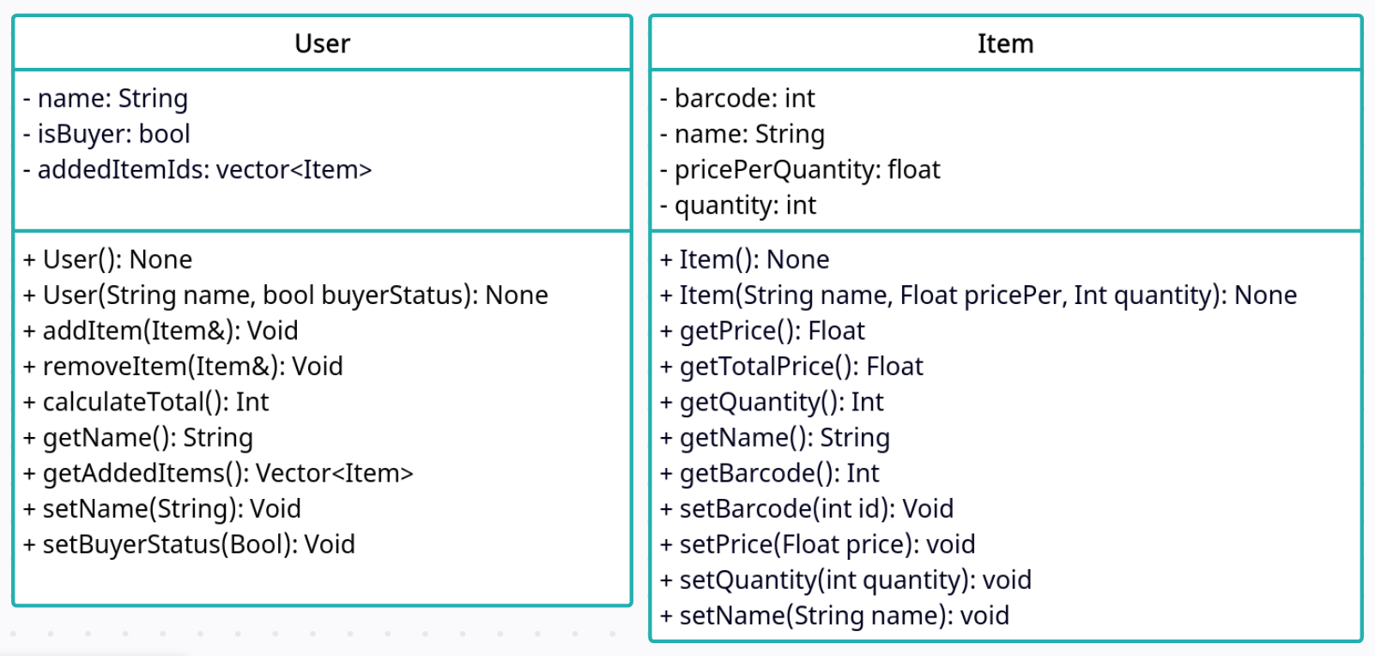
Most of the methods and attributes are self explanatory. The calculateTotal() method in “User” will take all of the items the user has added and add up their price, accounting for it multiple people have bought into an item. I am still considering how the items should be stored in the User class. The Diagram shows references to the Item class but I may use pointers/Values/ some other form of ID to keep track of the items instead. Depending on where I go with this, the addItem() and removeItem() methods of “User” will take in that identifier, and add/remove it from the addedItemIDs vector. The getTotalPrice() method of “Item” will multiply pricePerQuantity and quantity together and return the result. Most of the other methods are just Getters and Setters for the various attributes.
- List Incorporation:
I will use vectors to store information on the purchased items and users buying them. In the main scope of the program, I plan to use a vector of <Item> type and another vector of <User> type. There may also be vectors of references or pointers inside of the classes themselves.
- File IO
I will store purchase history and user buying history to a file so users can see what items they bought and how much they spent over time. This will write the data to a file that can then be read on request the next time the program is run.

PROCEDURAL DESCRIPTION:
Depending on how complex this project becomes, I would like to use SFML for graphics.

Include iostream, SFML, and any other required libraries
Include “User.h”, “Item.h”
Int main(){
Initialize vector<Users>;
Initialize vector<Items>;

Ask user to input participating user names;
Foreach name entered{
Create new “User” object with appropriate info;
Append user object to Users vector;
}

Ask user to input item names and prices, optionally barcodes;
Foreach item entered{
Create new “Item” object with appropriate info;
Append Item object to Items vector;
}

For each user{
Have user select items they are buying;
Update user’s object accordingly;
}
Calculate and display totals for each person and who to pay;

Write data to file for later viewing;
}
SPECIAL NEEDS/CONCERNS:
I plan to use SFML for graphics

